3918 Cooper Inspection Repairs Made:

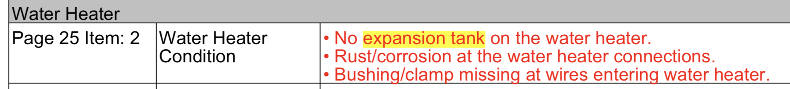
Repaired: Removed surface corrosion and added bushing clamp:

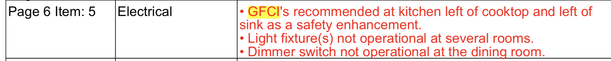
Repaired: Installed additional GFCI receptacles

Repaired holes in wall / baseboard:

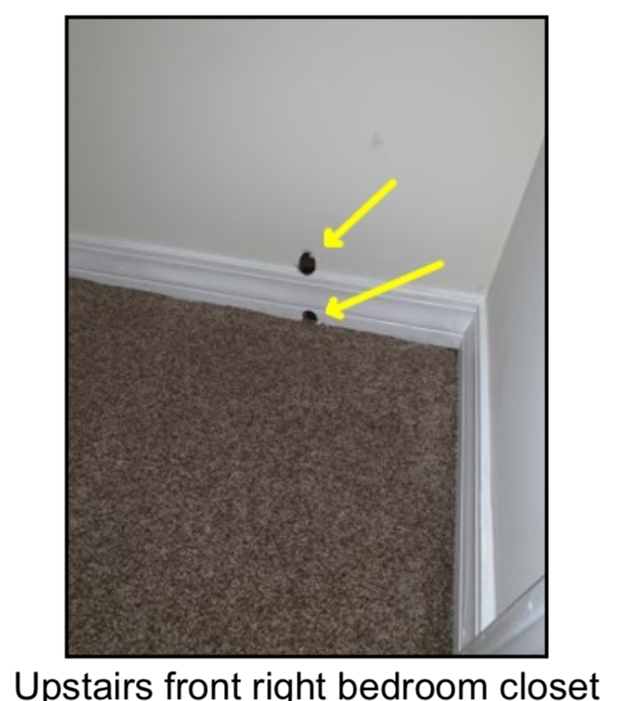

Repaired: Replaced receptacle with GFI protected receptacle

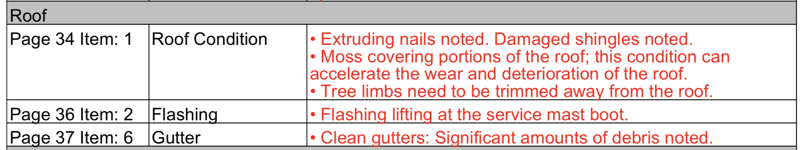
Repaired:
Moss washed / removed from roof
Gutters cleaned of leaves/debris (however, during fall, leaves collect in gutter)

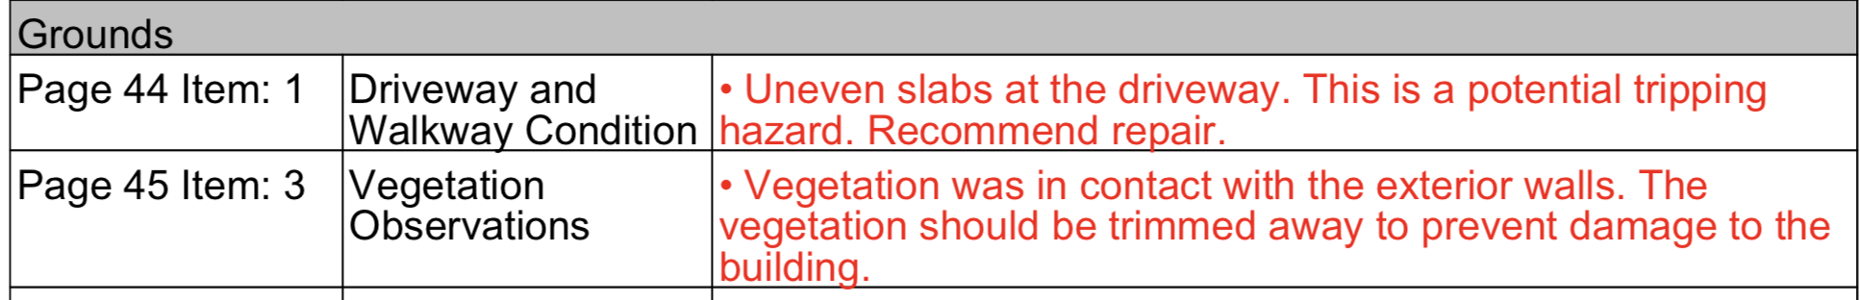

Repaired: Vegetation removed from exterior walls

Repaired: There was no leakage in the drain line, however, the duct tape was removed and drain line repaired with flexible coupling

